Execute Dag
1. Trigger the DAG from the Airflow UI (most common)
Once your DAG file is inside:
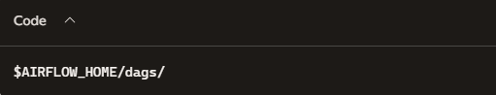
Airflow automatically loads it.
Then:
- Open Airflow UI → http://localhost:8080
- Find your DAG (example: dbt_orchestration)
- Flip the toggle ON
- Click Trigger DAG
That immediately starts the run.
2. Trigger the DAG from the Airflow CLI
If you prefer command-line execution:
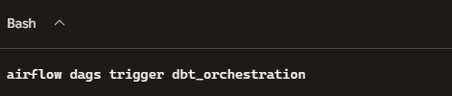

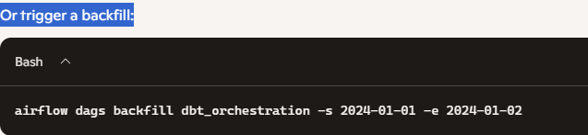

3. Let the scheduler execute it automatically
If your DAG has:
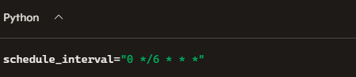
Airflow will run it every 6 hours without you doing anything.
Just make sure the scheduler is running:
